SINGAPORE INSTITUTE OF TECHNOLOGY | UNIVERSITY OF GLASGOW
Capstone Project Proposal
Development of a Digital Production Line Planning and Pre-Validation Tool

STUDENT
Ernest Sim 2401326
INDUSTRIAL CONTEXT
Gas turbine component repair and manufacturing operations
SUBMISSION
19 October 2026 | 5:00 pm

Background and Motivation

Industrial background
During my IWSP at GE Vernova Singapore Services (GEVSS), I was involved in work related to setting up a new production line for gas turbine component repair. I saw that the physical line was only one part of the work. Before any station could be set up, engineers had to confirm the process sequence, manpower needs, cycle times and how operators would move between stations.
Some of this planning is carried out through PQPR matrices, Yamazumi charts, line balancing, Standard Work Sheets (SWS), Standard Work Combination Sheets (SWCS) and table-top simulations. These tools are useful, but the information is often handled separately. When a process sequence or operator assignment changes, the same information may need to be checked and revised in several places.

Problem observed during IWSP
I also had the opportunity to take part in a table-top simulation with engineers, supervisors and operators. It helped me understand why these discussions are important. Operators could point out practical details that are easy to miss on paper, such as collecting tools, waiting for equipment, moving parts or completing inspections.
At the same time, I noticed that a fair amount of the session was spent going through the proposed sequence, workload and movement of parts. Much of this basic checking could have been done before gathering everyone together. Repeating the exercise to compare another layout or manpower arrangement would also take additional time.
This is particularly relevant in a repair environment, where different component framesizes may follow different process routes. Planning a line around only one route can overlook the effects of shared stations and uneven workloads when product types of change.

Motivation and problem statement
My intention is not to replace table-top simulation. The value of bringing experienced people together cannot be captured fully by a computer model. Instead, I want to develop a tool that allows engineers to prepare a more complete proposal before the discussion, so that time with operators can be spent checking feasibility, safety and improvement opportunities rather than repeating the initial calculations.

Problem statement
How can a digital production line planning and simulation tool make preliminary workflow validation more efficient, while keeping the practical input of engineers and operators in the final table-top simulation?

Proposed solution
The proposed solution is a web-based planning toolkit that brings process data, line balancing, station layout and discrete-event simulation into one workflow. The output will help users identify likely bottlenecks, compare alternative line arrangements and decide which issues still require physical validation. Its usefulness will be judged by the accuracy of its model and whether it reduces planning effort, not simply by the number of features developed.

Aim, Objectives and Scope

Project aim
To develop and evaluate a digital production line planning tool that helps engineers configure production lines, compare workflow options and carry out preliminary validation before a physical table-top simulation.

Objectives
- Develop process data and Yamazumi module to record manual and automatic times, show operator workloads and support line balancing.
- Build an interactive line layout tool in which users can assign processes to stations and position operators and compare alternative arrangements.
- Use Python and SimPy to model the flow of parts through stations, including process times, shared resources, queues and waiting.
- Allow different framesizes to follow applicable process routes and use PQPR information where available, without making PQPR a prerequisite for line balancing.
- Check simulation outputs against available production information and compare the effort required for manual and software-assisted planning.

Main functions and boundaries
Module | What it will allow a user to do
PQPR / process matrix | Record applicable processes and cycle times for each framesize.
Yamazumi and balancing | Break processes into work elements, review workloads and assign operators.
Line builder | Arrange stations and operators on a visual layout and save scenarios.
Discrete-event simulation | Test process routing, capacity, waiting time and resource utilisation.
Results comparison | Compare scenarios using throughput, station loading and bottlenecks.
The core project will focus on line planning and workflow simulation. Detailed modelling of rework, scrap rates and optimisation of batch quantities may be considered later if time and suitable data are available. The prototype will not control equipment or make final operational decisions.

How success will be evaluated
I will use at least one representative production workflow and compare two or more-line scenarios. The assessment will cover (i) whether calculated cycle times and bottlenecks are reasonable, (ii) whether the simulation is consistent with observed production data, and (iii) whether the time needed to prepare or revise a plan is reduced. If suitable industrial data cannot be shared, the same method will be demonstrated with clearly identified representative data, with that limitation stated.

Sustainability and Resources

Sustainability considerations
The main sustainability benefit I hope to demonstrate is more efficient use of engineering time and production resources. A digital planning exercise could reduce repeated printing, the need to rebuild simple planning mock-ups and the amount of unnecessary trial-and-error before a physical line change. However, I will treat these as possible benefits until there is evidence to support them.
From an economic perspective, being able to compare layouts and manpower assignments more quickly may reduce planning effort and highlight capacity constraints earlier. Socially, a clearer workflow may help engineers and operators discuss workloads and potential ergonomic concerns. The tool will still require operator input because a screen cannot fully represent access, fatigue, safety or shop-floor habits.

Resources required
Resource | Purpose
Python, Flask and SimPy | Backend, process logic and discrete-event simulation.
HTML, CSS and JavaScript | User interface, draggable layout and charts.
VS Code, Git and GitHub | Development, testing, version history and backup.
Approved production data | Process routes, manual/automatic time, work elements and resources.
Engineering / operations feedback | Review of assumptions and validation of practical use.
This is primarily a software project and does not require a physical prototype. Actual company data will be used only with permission; anonymised or synthetic values will be used where necessary.

Introduction to Sustainability — completion evidence
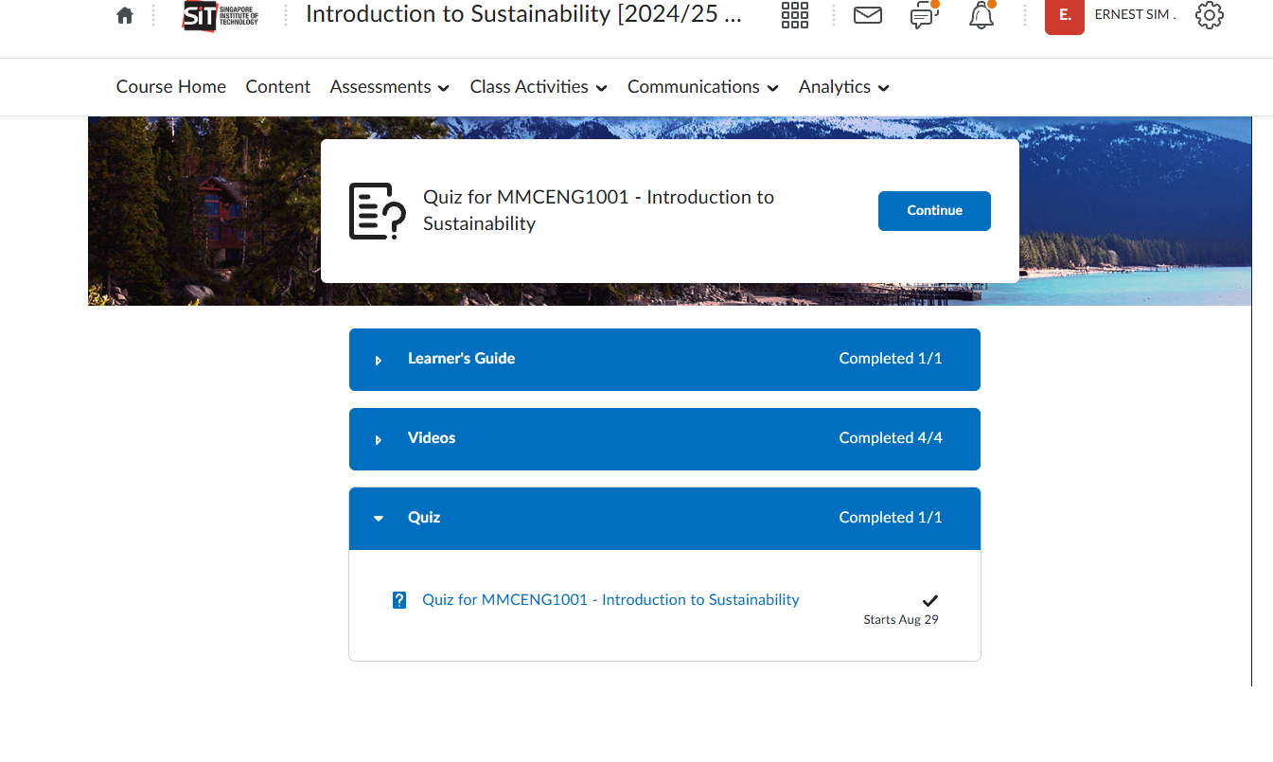
Screenshot retained from the supplied draft; module sections are shown as completed.

Project Planning
The application is already at an early prototype stage. I will use an iterative approach: improve each planning module, connect the modules into a consistent data flow and then test whether the model provides useful results. The weeks below are an indicative 12-week work plan and will be updated to match the approved capstone schedule.

Proposed Gantt chart (starting from Year 3 Trimester 2 week 1)
Work package | W1 | W2 | W3 | W4 | W5 | W6 | W7 | W8 | W9 | W10 | W11 | W12
Requirements, assumptions and scope
Prepare process data and test cases
Refine PQPR / Yamazumi / line balancing
Develop layout builder and operator logic
Build and test SimPy simulation
Add framesize routing and shared resources
Verify calculations and run scenario tests
Evaluate model and planning time saving
Final improvements, report and presentation
Dark cells indicate planned activity; the schedule allows tasks to overlap and be refined after testing.

Milestones and outputs
Milestone | Expected evidence | Timing
M1: Problem and data defined | Requirements, assumptions, process routes and sample data set | W2
M2: Planning modules working | PQPR, Yamazumi, line balancing and interactive layout | W6
M3: Simulation functional | Working SimPy model, test cases and scenario output | W9
M4: Validation and project close | Comparison results, limitations and final report | W12

A minimum viable outcome is a tested line-balancing and simulation workflow. Optional features will be developed only after the main model is reliable.

Risk Assessment

Assessment method
As the main project involves software development and simulation on a computer, the direct Workplace Safety and Health (WSH) risks are expected to be low. The tool will be used to review possible line configurations; it will not control machinery or authorize changes to the production line. Incorrect process data could affect the credibility of the study but would not by itself create a physical safety hazard within the project scope. I have therefore assessed workplace hazards separately from technical and project-related concerns.
Likelihood (L) and severity (S) are each rated 1 (low) to 5 (high). Risk score = L × S; 1–4 = Low, 5–9 = Medium and 10–25 = High. Residual ratings assume the proposed controls are carried out.

Risk register
Hazard / risk | Possible impact | Initial  L×S | Preventive action | Residual  L×S
Extended computer use | Eyestrain, fatigue or minor discomfort. | 2×2=4 (Low) | Use a suitable workstation and take regular breaks. | 1×2=2 (Low)
Loose cables or equipment at workstation | Trips, minor injury or electrical exposure. | 2×2=4 (Low) | Keep cables tidy; use approved, undamaged equipment. | 1×2=2 (Low)
Shop-floor observation (only if required) | Contact with moving equipment or materials. | 2×4=8 (Medium) | Seek site approval; follow existing RA, PPE rules and designated safe zones. | 1×4=4 (Low)

Technical and project-related risks
The need to manage incorrect cycle times, programming errors, confidentiality and delays from expanding the software scope. These concerns may reduce the quality of my results, but they are not direct WSH hazards for a pre-validation tool. I will check input data against available standard work, test calculations against known examples, keep company information in approved storage and review the outputs with engineers or operators before drawing conclusions. No simulation result will be treated as approval to change an actual line.

Risk Control and Validation

How risks will be controlled
I will check the tool in stages, beginning with individual cycle-time and workload calculations before running full simulations. Simple test cases will have known answers so that problems in the program are easier to find. I will also use Git to keep track of changes and avoid losing a working version while adding new functions.
For industrial data, I will only use information that I am permitted to access and present. Any shop-floor time study will follow site requirements, including approval, personal protective equipment and staying clear of operating equipment. I will not alter equipment or interfere with production as part of this project.

Verification and evaluation plan
Check | How I will assess it
Functional testing | Create, edit and remove work elements, assign stations and save a layout.
Model verification | Compare calculated workload and simulated time with simple manual calculations.
Model validation | Check throughput, waiting and resource use against available production observations.
Planning-time comparison | Time comparable manual and software-assisted line planning tasks.
User review | Ask relevant personnel whether outputs are clear and useful for discussion.
The evaluation will report both the improvements and limitations observed. If there is not enough reliable data to validate a certain behaviour, I will identify it as an assumption rather than present the result as proven.

Workplace Safety and Health Risk Management — completion evidence
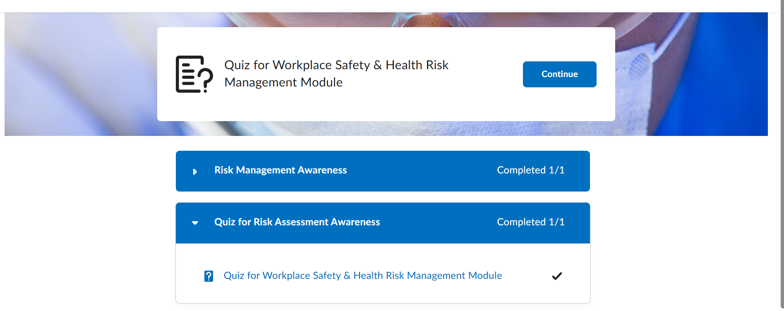
Expected contribution. The project aims to reduce repetitive planning work and give stakeholders a clearer starting point for line reviews, while keeping physical table-top simulations and operator judgement as the final check.

